6 Week Test
- Consider four charges, A, B, C, and D, which exist in a region of space. Charge A attracts B, but B repels C. Charge C repels D, and D is positively charged. What is the sign of charge A?
  - Positive
  - Negative
  - Neutral
  - All of the charges are positive
  - All of the charges are negative

- Consider two charged spheres of equal size carrying a charge of +8 C and – 4 C, respectively. The spheres are brought in contact with one another for a time sufficient to allow them to reach an equilibrium charge. They are then separated. What is the final charge on each sphere?
  - –4C
  - –2C
  - –1C
  - +1C
  - +2C

- An insulator differs from a conductor in that -
  - insulators are usually metals
  - a conductor resists the flow of charge
  - an insulator has a small number of free electrons
  - an insulator has a large number of free electrons
  - a conductor has more atoms than an insulator

- Two conducting spheres of equal size have a charge of – 3 C and +1 C, respectively. A conducting wire is connected from the first sphere to the second. What is the new charge on each sphere?
  - –4C
  - +4C
  - –1C
  - +1C
  - Zero

- Two charges q1 and q2 are separated by a distance r and apply a force F to each other. If both charges are doubled, and the distance between them is halved, the new force between them is
  - F/4
  - F/2
  - 4F
  - 8F
  - 16F

- Two charges are separated by a distance r and apply an electric force of 4 newtons on each other. If one of the charges is brought closer to the other charge so that they are only half as far apart as before, the force between the two charges will be
  - 1N
  - 2N
  - 4N
  - 8N
  - 16N
Four charges are arranged in a square as shown in the figure.
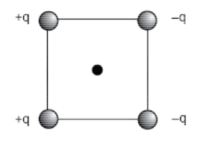
- Which of the following is the direction for the force that would be felt by a small, positive charge located at the center of the square?
  - Left
  - Right
  - Up
  - Down
  - Up and Left.

- The electric field at the center of the square would be directed -
  - Up
  - Down
  - Left
  - Right
  - Right and Down.

- The electric potential at the center of the square is -
  - positive
  - negative
  - zero
  - directed to the left
  - directed to the right

- A ball is dropped from a height of 1 meter. At the same time, an identical ball is then rolled off of a 1-meter high table, with an initial horizontal speed of 2 m/s. Which ball hits the ground first?
  - The ball that was dropped.
  - The ball that was rolled off the table.
  - Both balls hit the ground at the same time.
  - It cannot be determined without knowing the mass of the ball.
  - It cannot be determined without knowing the distance the second ball had rolled.

- An electron is traveling to the right, when it enters a region of space where a uniform magnetic field is directed into the page. The force on the electron is directed -
  - up
  - down
  - left
  - right
  - out of the page.

- A proton is traveling toward the top of the page, when it enters a region of space where a uniform magnetic field is directed out of the page. The path of the proton is best described as -
  - A circle or spiral
  - A parabola
  - A hyperbola
  - An ellipse
  - it cannot be determined from the information given.

- A non-magnetic spaceship has a net charge of 0.25 C at it travels to the left. It approaches a magnetar, which generates a magnetic field of 12 T, directed out of the page. What force (magnitude and direction) should the captain order the engines to be set at in order to cancel the effects of the magnetic field on the ship?

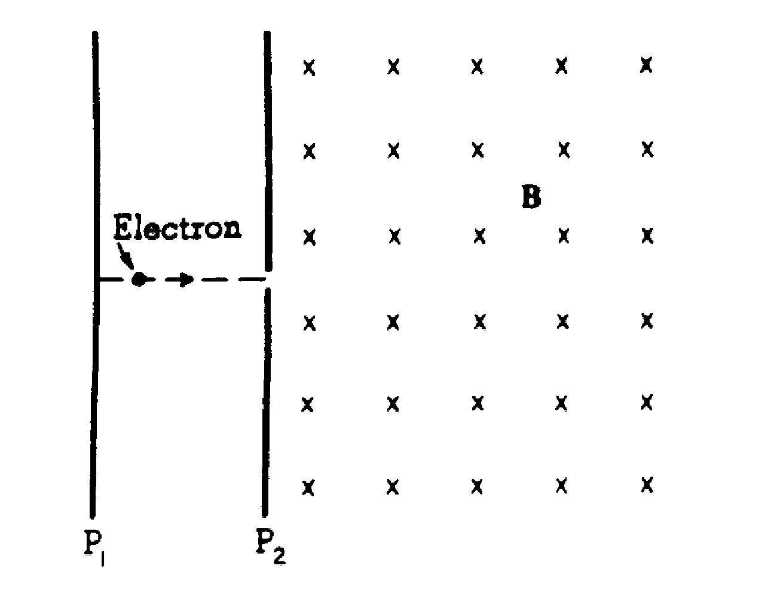
- An electron is accelerated from rest through a potential difference of magnitude V between infinite parallel plates P₁ and P₂.· The electron then passes into a region of uniform magnetic field strength B which exists everywhere to the right of place P₂. The magnetic field is directed into the page.
  - On the diagram above, clearly indicate the direction of the electric field between the plates.

  - In terms of V and the electron's mass and charge, determine the electron's speed at plate P₂.

  - Describe in detail the motion of the electron through the magnetic field and explain why the electron moves this way.

  - If the magnetic field remains unchanged, what could be done to cause the electron to follow a straight-line path to the right of plate P₂?

